Elastic Load Balancing automatically distributes incoming application traffic across multiple targets, such as Amazon EC2 instances, containers and IP addresses

There are 3 types of ELB on AWS

1. CLB – Classic Load Balancer – this is the oldest of the three and provides basic load balancing at both layer 4 and layer 7.
2. ALB – Application Load Balancer – Layer 7 load balancer that routes connections based on the content of the request.
3. NLB – Network Load Balancer – Layer 4 load balancer that routes connections based on IP protocol data.

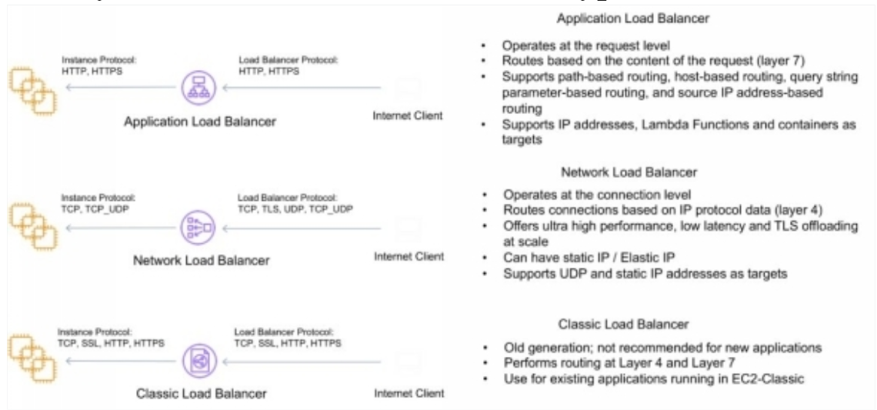

Elastic Load Balancing provides fault tolerance for applications by automatically balancing traffic across EC2 instances, containers and IP addresses – and availability zones which ensuring only healthy targets receive traffic.

Only 1 subnet per AZ can be enables for each ELB

**Listeners:**

1. Listeners for CLB provide options for TCP and HTTP/HTTPS.
2. Listeners for ALB only provide options for HTTP and HTTPS.
3. Listeners for NLB only provide TCP as an option.
4. Deleting an ELB does not affect the instances registered against it (they wont be deleted, they just won’t receive any more requests).
5. For ALB at least 2 subnets must be specified.
6. For NLB only one subnet must be specified (recommended at least 2)

**Target Groups:**

1. Target groups are a logical grouping of targets instances or EC2.
2. Targets are the end points and can be EC2 instances, ECS containers or IP addresses.
3. Target groups can exist independently from the ALB.
4. Target groups can have up to 1000 targets.
5. Only one protocol and one port can be defined per target group.

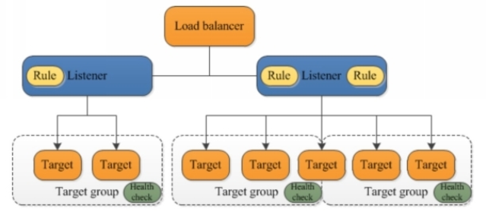

In the above picture if you notice that each listener contains a default rule, and one listener container another rule that routes requests to a different target group. One target is registered with 2 target groups.